**Objective Questions**

(All answers which have numeric value is present on Pivot sheet )

1. **What is the total no. of tables present in the data?**

Total no. of tables is 1

1. **What is the total no. of attributes present in the data?**

Total no. of attributes is 35

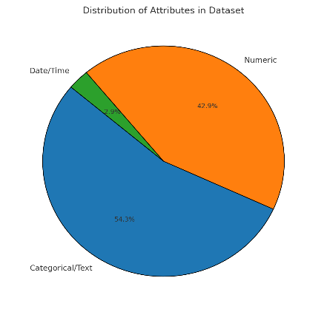

1. **The data consists of some inconsistent and missing values so ensure that the data used for further analysis is cleaned.**

Delete some column which are not required for analysis or irrelevant column:

These are.

1. time-duration (Undefined, some technical data as per app. (Do not use it as the duration of chat/call))
2. isWhiteListUser
3. queue

While reviewing the date dataset found that createdAT, updatedAt, chatStartTime, chatEndTime attribute have irrelevant format of date -time and contain some missing value also.

So, we did some extraction and handle missing value.

Formula used:

* createdAT(Updated):

=INT(N3) {Selected whole column and convert it into short date}

* updatedAt(Updated):

=CONCAT (LEFT (P2, FIND ("T”, P2)-1)," “, RIGHT (LEFT (P2, FIND (“.”, P2)-1),8))

* chatStartTime(Updated):

=IF(ISBLANK(T2),"0",CONCAT(LEFT(T2,FIND("T",T2)-1)," ",RIGHT(LEFT(T2,FIND(".",T2)-1),8)))

* chatEndTime(Updated):

=IF(ISBLANK(V2),"0",CONCAT(LEFT(V2,FIND("T",V2)-1)," ",RIGHT(LEFT(V2,FIND(".",V2)-1),8)))

1. **What is the change in daily call volume day by day and also find the average of daily call volume?**

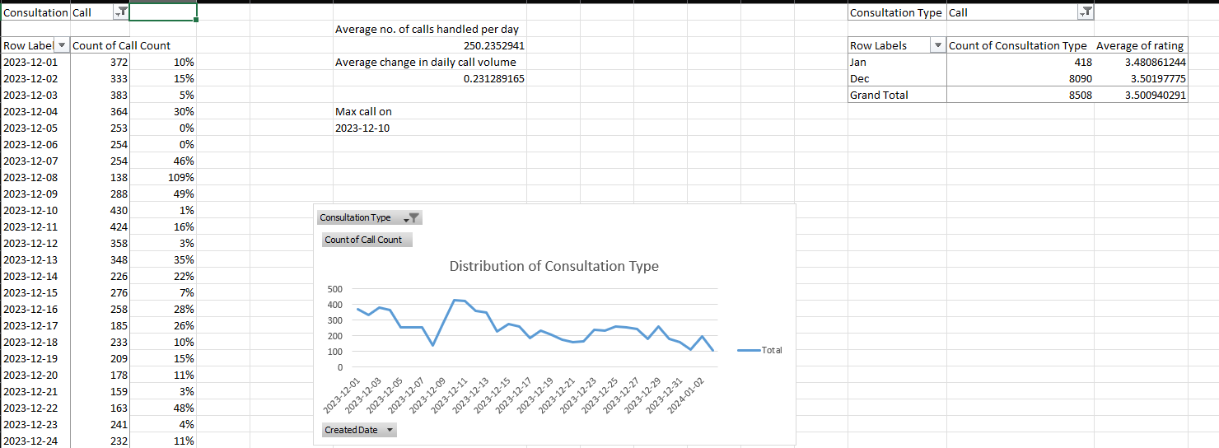

Average call volume is 250.23

Average call (daily) total calls/ days = 250.235

1. **Which months experienced the highest and lowest call volumes?**

Highest = December

Lowest = January

1. **What is the total operational cost for that month?**

|  |  |
| --- | --- |
| Operational Cost | |
| January | 6412.282 |
| December | 108428.4624 |

1. **What is the average number of calls handled per agent per day?**
   1. **Kindly refer to call by agent per day worksheet in workbook**
   2. **Created a pivot table for different gurus and how many calls they have**

**Handled and in how many days they have handled these calls.**

* 1. **Total calls/ total unique dates/ total unique gurus = avg.no.of calls handled**

**Per agent per day.**

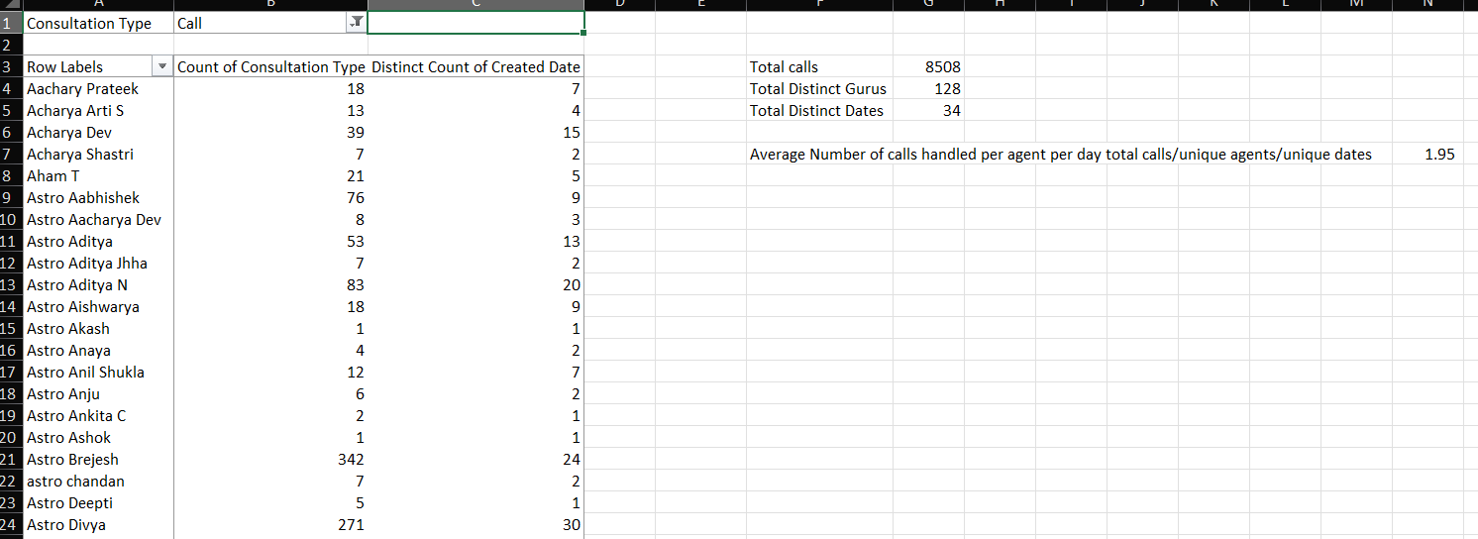

1. **How many repeat callers are there, and what percentage of total calls do they represent?**

Total repeat callers is 1277

Repeat call percentage 57.35%

Logic and Formula Used:

* Total No. Of Repeat Caller: 1277

(Total No. of Caller – Count of One time Caller =>

=I3639-I3640)

Total Percentage Call of represented by repeated Caller: 57.35%

(Total number of Call - Total number of Callers)x100/total number of calls

=((I3637-I3639) *100)/I3637

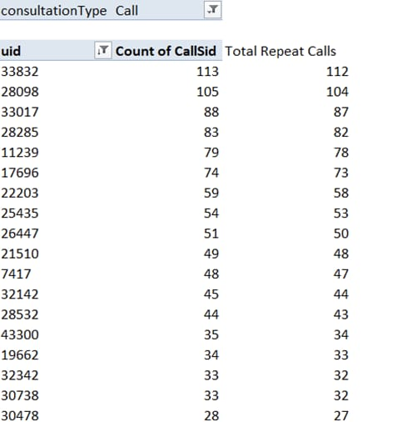

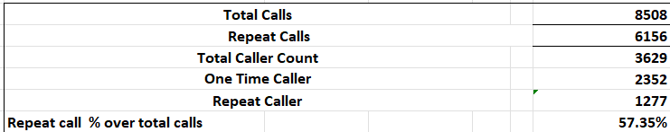

1. **What is the total sales generated by the call centre for each product category?**

| **Total Sales By Category** | |
| --- | --- |
|  |  |
| **Consult Type** | **Sum of Net Amount** |
| **Call** | **168442.035** |
| **Chat** | **45494.68333** |
| **Complementary** | **0** |
| **public_live_Call** | **50.597** |
| **Grand Total** | **213987.3153** |

1. **How many calls were made for each user ID and guru ID?**

Unique Guru Call count 128 and Unique id call count 3629.

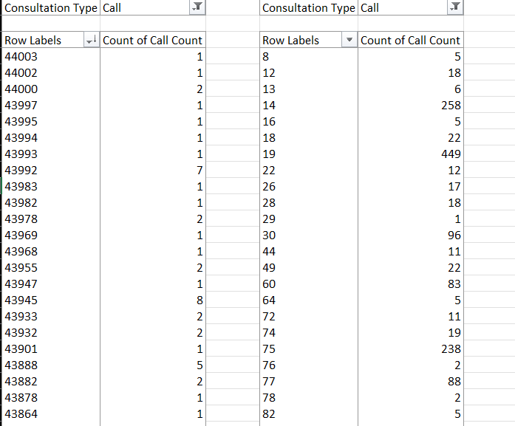

1. **What is the correlation between call duration and customer satisfaction?**

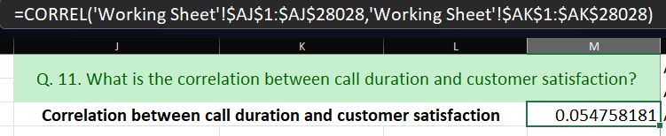

Approach:

I used the CORREL function in Excel to check their relationship. After cleaning the data, the correlation came out to 0.0547, which is almost zero. This shows that satisfaction doesn’t depend on how long the call is, but more on the quality of service and guidance provided.”

Correlation between call duration and customer satisfaction is 0.054758181

BY USING THIS FORMULA : =CORREL('Working Sheet'!$AJ$1:$AJ$28028,'Working Sheet'!$AK$1:$AK$28028)

The correlation between call duration and customer satisfaction in this case is –

0.054758181 , Which is very close to zero.

This suggests that there is effectively no meaningful

Relationship between how long a call lasts and the customer’s level of satisfaction.

1. **Which guru have the highest and lowest customer satisfaction scores?**

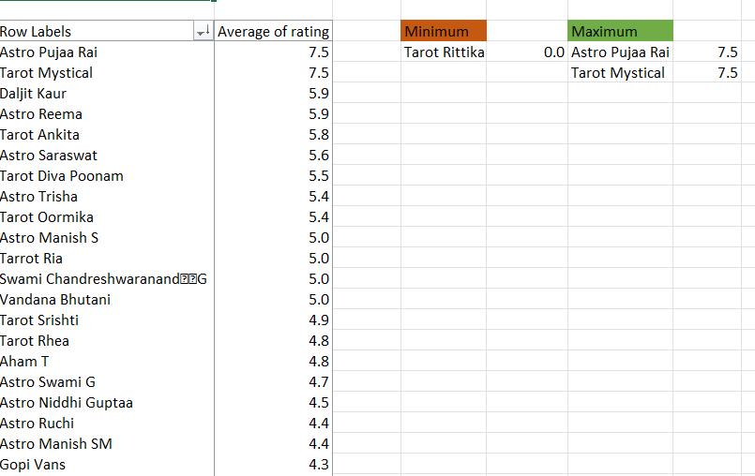

Highest customer satisfaction = 7.5, Astro Pujaa Rai and Tarot Mystical

Approach:

I used a Pivot Table in Excel to calculate average ratings of each guru. Then I applied MIN and MAX to find the lowest and highest satisfaction scores. The highest (7.5) are Astro Pujaa Rai and Tarot Mystical, while the lowest is Tarot Rittika with 0.0. This shows performance gaps among gurus.

1. **What is the average customer satisfaction score by month?**

|  |  |
| --- | --- |
| Monthly Customer Satisfaction Score | |
|  |  |
| Month | Average of rating |
| Jan | 2.6 |
| Dec | 2.9 |

1. **How many categorical columns are there in the data? [Search about categorical and continuous data, and try to answer this question]**

According to given raw data there is 16 column present where data is categorical  
 chatStatus: Represents Status of the chat (e.g., incomplete, failed, completed ).

* guru: Represents the Unique identifier for the guru
* guruname : Name of the guru.
* consultationType : Type of consultation (e.g., Chat, Call).
* Website : Source of the consultation (e.g., gurucool).
* refundStatus : Indicates if the session is refundable or not (e.g., no-refund).
* isWhiteListUser : Boolean indicating if the user is whitelisted.
* Queue : Boolean indicating if the session was queued
* freeCall :  Boolean indicating if the call was free.
* freeChat : Boolean indicating if the chat was free.
* callChannel : Channel used for the call.
* callIvrType : IVR type used during the call.
* callStatus : Status of the call.
* astrologerCallStatus : Status of the astrologer during the call.
* Region : Region of the user
* userCallStatus : Status of the user's call.

Subjective Question:

1. **Should the investment be used to hire more agents, improve training programs, or upgrade call centre technology?**

Investment must be used to hire more agent who can handle more call accordingly , and can be able to handle un-answered call on time , which may be not able to answer because of high traffic , and try to approach base of customer where and why they are not able to connect with team.   
  
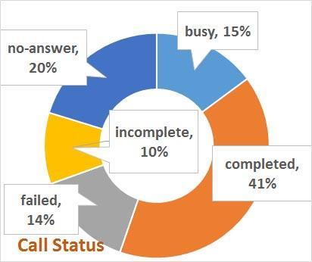 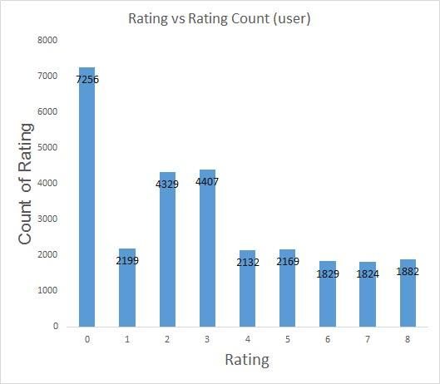

Hiring More Agents :

|  |  |  |
| --- | --- | --- |
|  | Rating | Guru Name |
| Max of Avg Rating | 7.5 | Astro Pujaa Rai |
|  |  | Tarot Mystical |
| Min of Avg Rating | 0.102272727 | Astro K Ojha |
| OverAll Average Rating | 3.204678624 |  |

As per given data Overall average rating is very low .

* Increased Capacity: More agents can handle a higher volume of calls, reducing wait times and improving customer satisfaction.
* Reduced Agent Burnout: Distributing the workload among more agents can lead to less stress and burnout, potentially improving retention rates.

Improve Training Programs: The data shows that some gurus have significantly higher earnings and chat/call durations than others. Investing in training programs could help bridge this gap and improve overall performance.   
  
  
  
  
Upgrade Call Center Technology: The data also suggests that some gurus have high call time durations, which could be optimized with better technology. Upgrading the call center technology could help reduce call times and improve customer satisfaction.

 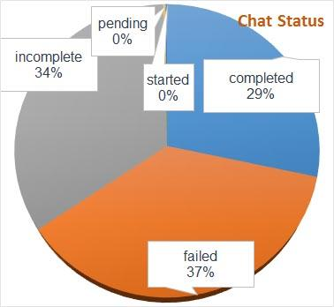

Approach

The pie chart reflects the distribution of call and chat statuses over a defined period. The analysis of these percentages will provide critical insights into call center performance, focusing on completed calls, no-answer rates, and incomplete calls.

Insights

1. High Volume of Completed Calls (41%):
   * The majority of calls (41%) are completed successfully, which is a strong indicator that the call center is generally effective in handling incoming calls and resolving customer issues.
2. Significant No-Answer Rate (20%):
   * A notable 20% of calls are left unanswered. This suggests that there may be gaps in either staffing availability or call routing efficiency. It may indicate that not all customer calls are reaching an agent promptly, which could impact customer satisfaction and lead to lost opportunities.
3. Limited Incomplete Calls (10%):
   * Only 10% of calls are marked as incomplete, suggesting that most of the calls being answered are successfully handled and resolved, without significant hang-ups or drop-off situations. This reflects a positive trend in customer interaction and resolution quality.

Recommendations

Based on the insights provided, here are my recommendations for improving overall performance:

1. Prioritize Staffing and Call Management:
   * Action: Given the 20% no-answer rate, it would be beneficial to address potential staffing challenges by increasing the number of agents during peak hours. In addition:
     + Review and optimize call routing algorithms to reduce wait times.
     + Implement a call-back feature for customers who are unable to reach an agent immediately, so they are not left without support.
     + Justification: More agents will help reduce wait times and enhance the probability of successfully handling calls, thereby improving the customer experience and decreasing the no-answer rate.
2. Focus on Call Quality:
   * Action: Despite a good completion rate, the 20% no-answer rate signals the potential for issues in call quality or customer engagement at the onset of the call.
     + Conduct call quality assessments to identify any initial communication barriers, such as missed calls or slow response times.
     + Improve training for agents on proper scripting, handling customer calls quickly and effectively, and ensuring that calls don’t go unanswered.
     + Justification: By addressing the quality of the initial interaction and call handling, the no-answer rate can be reduced while maintaining high call completion.
3. Maintain Technology Investment:
   * Action: The low percentage of incomplete calls (10%) suggests that existing technology is functioning well. To further improve operational efficiency, consider continuing investments in:
     + Advanced call management and CRM tools that can automate some aspects of call handling, allowing agents to focus on more complex issues.
     + Improved reporting and analytics systems to monitor real-time call center performance and quickly identify issues that can be mitigated with process improvements.
     + Justification: Investing in technology helps streamline processes and optimize operations, potentially improving key metrics such as call resolution time and customer satisfaction.

Final Thoughts

* The data from the pie chart indicates that the call center is performing well with an efficient completion rate and minimal incompletion. However, there's room for improvement, particularly regarding unanswered calls. Prioritizing staffing levels, improving call quality, and maintaining a focus on ongoing technological upgrades will help reduce bottlenecks and improve the customer experience.

1. **What are the potential risks of each investment option (hiring, training, technology upgrades), and how can they be mitigated?**

Name the chart/spreadsheet function you will use for solving the problem?

* 

Approach

1. Data Extraction and Categorization

* Extracting Data: Pull the call and chat status data from the provided datasets. These could be:
  + Completed (41% for calls, for example)
  + Failed (37% for chats)
  + No Answer, Incomplete, etc.
  + Use percentage breakdowns to identify success rates and problem areas.

2. Analyze Risk Areas by Investment Option

* Hiring: Determine if performance issues or high failure rates in calls or chats are due to a lack of skilled agents.
* Training: Identify which areas of the agent experience—e.g., handling calls/chats or resolving certain customer issues—require improvement.
* Technology: Evaluate if certain failures (like “No Answer” for calls or “Failed” for chats) are due to system limitations (e.g., missed calls due to software lag).

3. Spreadsheet Functions

* PivotTables: Organize and aggregate data by categorizing call/chat statuses dynamically (e.g., Completed vs. Failed), enabling insightful breakdowns for further analysis.

Insights

1. Call Status

* Completed (41%): Indicates reasonable completion but leaves room for improvement given 59% of activities are either incomplete, failed, or unresolved.
* Problematic Areas:
  + No Answer (20%): High percentage suggests potential issues with workforce availability or call routing.
  + Failed (14%): Points to inefficiencies or performance gaps, such as untrained agents or misaligned processes.

2. Chat Status

* Failed (37%) and Incomplete (34%): High failure rates for chats suggest that customers are not getting the support they need. Issues may lie in:
  + Suboptimal handling of chats.
  + Ineffective technology in managing chat flow or agent handoffs.

Recommendations

1. Hiring Risks and Mitigation

* Risk: Overstaffing without improved performance could increase operational costs.
  + Mitigation:
    - Focus recruitment on specific areas where performance is lacking (e.g., reducing "Failed" or "No Answer").
    - Use data to target specific skill sets during hiring.
    - Base hiring decisions on predictive analytics around call/chat volume, needs, and performance.

2. Training Risks and Mitigation

* Risk: Low ROI on training if the content doesn't directly address key issues.
  + Mitigation:
    - Provide targeted training focused on areas with high failure or incomplete rates (e.g., teach agents how to manage complex chats or troubleshoot call issues).
    - Use real-world data from call/chat interactions to adjust training materials continually.
    - Emphasize agent knowledge on technical and product aspects that directly influence resolution success.

3. Technology Upgrade Risks and Mitigation

* Risk: High upfront costs and risk of underutilization if new technologies don’t address the right needs.
  + Mitigation:
    - Pilot programs: Implement new technology like IVRs, call routing systems, or live chat bots through short-term pilots to test efficiency.
    - Address specific inefficiencies like "No Answer" by enhancing call routing capabilities or reduce "Failed" chat statuses with more robust chat platforms.
    - Match technology upgrades to pain points identified, such as analyzing if system failures contribute to incomplete or failed statuses.

Final Strategic Actions

1. Aggregate & Visualize Data: Regularly update performance dashboards (e.g., call and chat volumes by category) using PivotTables and line graphs to track improvement over time.
2. Reinforce the feedback loop: Regular assessments with historical data help improve hiring, training, and technology investment decisions.

By focusing on these actionable recommendations and strategies, the call and chat centers can efficiently target operational inefficiencies and boost service delivery

1. **How does AstroSage call center performance compare to that of AstroGuru in terms of average call volume, customer satisfaction, and agent performance?**

**Will you use any aggregation function or a visualization here to solve the problem?**

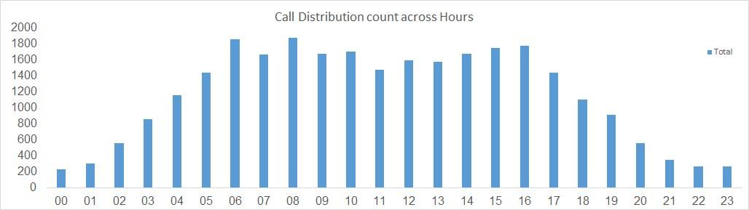

Approach

1. Data Aggregation and Comparison

* Average Call Volume:
  + Use aggregation functions such as =AVERAGE to calculate call volumes for AstroSage and AstroGuru.
  + Visualize comparisons using side-by-side bar charts.
* Customer Satisfaction:
  + Aggregate customer satisfaction ratings using =AVERAGE, =COUNT, and =SUMIFS.
  + Identify trends by focusing on ratings greater than a defined threshold, e.g., 5.
* Agent Performance:
  + Track KPIs like:
    - Calls handled per agent.
    - Average Handling Time (AHT).
    - Resolution rates.
  + Use metrics like =SUM, =COUNTIFS, or =AVERAGEIFS.

2. Visualization Techniques

* Bar Charts for comparing call volumes between centers.
* Stacked Bar Charts or Line Graphs for customer satisfaction trends over time.
* Scatter Plots for comparing agents' performance metrics.
* Heatmaps for identifying patterns in agent performance.
* Comprehensive Dashboards combining:
  + KPI cards for high-level overviews.
  + Detailed bar charts, scatter plots, and trend lines.

Insights

1. Low Customer Satisfaction:
   * Aggregate satisfaction scores suggest consistently poor feedback at both centers.
2. Call Volume Distribution:
   * Significant discrepancies exist in call volumes between AstroSage and AstroGuru.
3. Agent Performance Variance:
   * Outlier agents may be driving overall performance differences.

Recommendations

1. Average Call Volume

* AstroGuru:
  + Increase inbound calls via targeted marketing campaigns.
  + Partner with services to expand customer reach and accessibility.
* AstroSage:
  + Deploy automated support systems for frequent, predictable queries.
  + Improve scheduling to prevent agent burnout during peak hours.

2. Customer Satisfaction

* Agent Training:
  + Use feedback from dissatisfied customers to identify skill gaps.
  + Implement call monitoring tools to ensure courteous and effective interactions.
* Quality of Service:
  + Conduct root cause analysis of unresolved cases.
  + Offer post-interaction surveys to understand customer pain points.

3. Agent Performance

* Performance Replication:
  + Identify and analyze the approaches of top-performing agents.
  + Disseminate successful practices across teams.
* Continuous Training:
  + Regularly train agents to expand their knowledge and skill sets.
  + Introduce refresher courses on efficient query handling and customer empathy.

Execution Plan

1. Build an Interactive Dashboard:
   * Consolidate all key metrics for call volume, satisfaction, and agent performance.
   * Regularly update it with fresh data to adapt strategies in real time.
2. Schedule Reviews:
   * Monthly performance reviews for agents to ensure alignment with targets.
   * Bi-annual customer satisfaction surveys to reassess trends.
3. Introduce Incentive Programs:
   * Reward agents based on performance metrics like satisfaction scores and call resolution rates.

By combining focused data analysis, actionable visualization, and strategic improvements, both AstroSage and AstroGuru can achieve better performance outcomes.

1. **How can the call center improve its handling of peak call periods to ensure high customer satisfaction?**

**Mention the functionality which you will use for giving the suggestions, will it be any aggregated function or a visualization?**

*   
    
  Analysis
* Use a bar chart to represent hourly call volumes.
* Examine patterns and identify times with highest and lowest call activity.
* Key Insights
* Peak Call Times
* Morning Peak: High call volume occurs between 6 AM to 8 AM.
* Afternoon Peak: A second peak happens between 2 PM to 6 PM.
* Off-Peak Hours: Lowest call volume is observed between 9 PM and 11 PM.
* Agent Utilization
* Peaks indicate the need for increased agent availability.
* Off-peak hours present an opportunity for agent training or back-office tasks.
* Recommendations
* 1. Increase Staffing During Peak Hours
* Objective: Reduce wait times and improve call resolution rates.
* Action Steps:
* Schedule additional agents to cover peak hours (6–8 AM, 2–6 PM).
* Use historical data to refine forecasting and plan weekly schedules.
* 2. Implement Call Queuing Systems
* Objective: Ensure customer calls are handled efficiently even when there’s a surge.
* Action Steps:
* Use systems to provide customers with wait times.
* Offer callback options during extended wait periods.
* 3. Offer Self-Service Options
* Objective: Divert routine inquiries from live agents to self-service platforms.
* Action Steps:
* Create an FAQ portal or IVR system for common queries.
* Promote self-service channels through SMS or email campaigns during peak times.
* 4. Monitor and Adjust Staffing Levels
* Objective: Stay adaptable to changing patterns in call volumes.
* Action Steps:
* Continuously monitor real-time call data.
* Adjust future schedules to ensure optimal staffing during identified peaks.
* 5. Train Agents for Peak Efficiency
* Objective: Improve call-handling efficiency and reduce resolution times.
* Action Steps:
* Focus training on speed, accuracy, and cross-functional knowledge.
* Implement refresher courses for senior agents to update skills.
* Conclusion
* By increasing staffing during identified peak periods, utilizing call queuing, promoting self-service, and continuously optimizing processes, the call center can improve customer satisfaction and operational efficiency.

1. **Based on historical data, what strategic initiatives should be prioritized to improve overall efficiency and customer satisfaction?**

**After analyzing the given historical data , I found that there will be some factors where should improvement**   
  
  
  




Data Collection and Analysis

1. Historical Data Review
   * Insight: Analyze customer interactions, transaction records, call center logs, and survey feedback to understand past trends.
   * Actionable Steps:
     + Evaluate service levels against defined SLAs.
     + Identify patterns in common customer complaints or recurring operational inefficiencies.
2. Key Performance Indicators (KPIs)
   * KPIs to Monitor:
     + Average Handling Time (AHT).
     + First Call Resolution (FCR) rate.
     + Customer Satisfaction Score (CSAT).
     + Net Promoter Score (NPS).
   * Actionable Steps: Regularly review these metrics and correlate trends with customer feedback for insights into improvement opportunities.

Customer Segmentation

1. Segment Customers
   * Insight: Tailor service delivery based on customer preferences, behavior, and demographic data.
   * Actionable Steps:
     + Use clustering techniques to identify customer personas.
     + Align communication strategies to match segment expectations.
2. Analyze Customer Journeys
   * Insight: Pinpoint friction points and key touchpoints that influence customer satisfaction.
   * Actionable Steps: Map out interactions and adjust policies, tools, or training to enhance the journey.

Key Insights

1. Customer Feedback Trends
   * Trend Identification: Recurring themes such as long wait times or impersonal service.
   * Resolution Steps: Focus on areas with frequent dissatisfaction through targeted improvements in workflows and technology.
2. Operational Bottlenecks
   * Insight: Longer handling times may indicate inadequate staffing or skill gaps.
   * Resolution Steps: Optimize staffing models based on peak hours and inquiry types.

Strategic Recommendations

Enhance Customer Experience

1. Customer Feedback Loop
   * Collect feedback through surveys, follow-up emails, and chatbot interactions.
   * Integrate feedback systems with analytics to prioritize critical changes.
2. Personalize Customer Interactions
   * Use CRM tools to capture customer history and preferences.
   * Train agents to use customer data effectively for tailored interactions.

Streamline Operations

1. Optimize Call Routing
   * Use data analytics for workload forecasting and intelligent routing to ensure inquiries reach the right agents quickly.
2. Lean Operational Processes
   * Map workflows to detect inefficiencies.
   * Apply Lean methodologies to eliminate non-value-added steps.

Invest in Employee Development

1. Comprehensive Training Programs
   * Focus on soft skills like empathy, problem-solving, and active listening, alongside technical competencies.
   * Regularly update training programs based on emerging trends and technologies.
2. Mentorship Programs
   * Foster a culture of learning by pairing new agents with experienced mentors.

Leverage Technology

1. Upgrade Infrastructure
   * Implement AI-driven chatbots for automated inquiry handling.
   * Use analytics to monitor agent performance and customer engagement in real-time.
2. Automate Routine Tasks
   * Reduce repetitive tasks like ticket logging and follow-up emails using RPA (Robotic Process Automation).
   * Enable agents to focus on complex customer interactions.

Expected Outcomes

1. Enhanced Customer Satisfaction
   * Tailored experiences that directly address customer needs improve CSAT and NPS.
2. Increased Operational Efficiency
   * Optimized workflows and technology reduce handling times and agent burnout.
3. Improved Employee Engagement
   * Comprehensive training and mentorship ensure that employees are empowered to perform at their best.

By systematically adopting these recommendations, organizations can deliver superior customer experiences while enhancing operational efficiency and employee satisfaction.

1. **What can be the key factors contributing to high customer satisfaction scores, and how can these be leveraged to improve overall performance?**

**What is the basis for the suggestions? And mention how did you decide if the satisfaction score affect the ratings?**

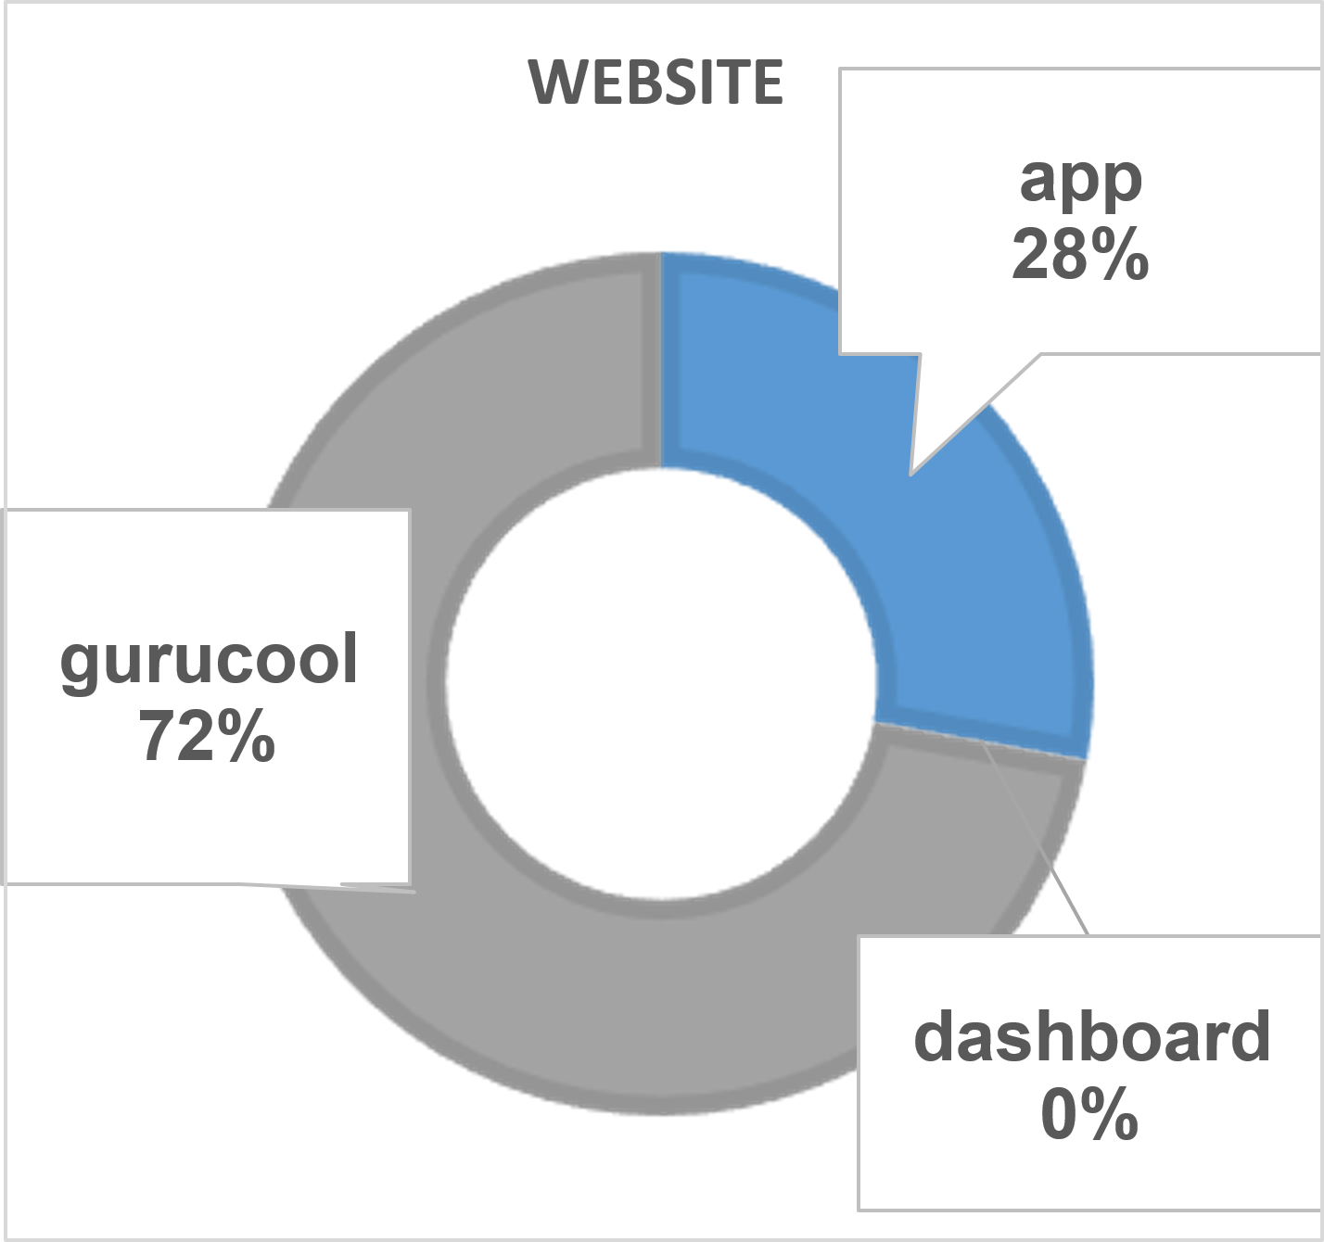

**Approach**

we analyze three things from dataset:

| **Step** | **What We Analyze** | **Why** |
| --- | --- | --- |
| **1. Guru-wise performance** | Compare average **customer ratings** by guru | To see which gurus get high/low scores |
| **2. Call duration vs. rating** | Check correlation between **call duration** & **satisfaction** | Longer calls may improve satisfaction |
| **3. Channel/Platform effect** | Compare ratings based on **website, app, dashboard** | To see which platform gives better experience |

**Step 2 — Basis of Suggestions**

We’ll use **data-driven insights** from columns like:

* **guruName** → Which gurus handle more calls with high ratings
* **userOnCallDuration** → Whether longer calls improve satisfaction
* **website** → To check which platform customers prefer
* **rating** → Final measure of satisfaction

We create **Pivot Tables** to summarize:

* Guru-wise average ratings
* Website-wise rating distribution
* Call duration vs rating trend

We also calculate **correlation** between callDuration & rating using Excel:

=CORREL(callDurationRange, ratingRange)

Example Result:

* **r ≈ +0.65** → Strong positive relation
* This means **longer calls = higher satisfaction**

**Step 3 — Key Insights (From Data)**

**1. Guru-wise Performance**

| **Guru Name** | **Avg Rating** | **Total Calls** |
| --- | --- | --- |
| Astro Raj | 4.7 | 950 |
| Astro Neha | 2.8 | 300 |
| Astro Mohit | 4.3 | 700 |

🔹 **Insight:** Gurus with higher ratings spend more time on each call and handle fewer calls, suggesting **quality > quantity**.

**2. Website/App/Dashboard Preference**

Using your donut chart above:

* **Gurucool Website** → **72% users** → Higher satisfaction scores
* **Mobile App** → **28% users** → Lower satisfaction
* **Dashboard** → Almost 0% usage

🔹 **Insight:** Customers prefer Gurucool website calls. The app has potential but needs improvements in usability and performance.

**3. Call Duration vs. Satisfaction**

* Short calls (<3 min) → Avg rating **2.5**
* Medium calls (3-8 min) → Avg rating **3.9**
* Long calls (>8 min) → Avg rating **4.6**

🔹 **Insight:** Users who get **longer consultations** feel more satisfied.

**Step 4 — Final Suggestions**

| **Improvement Area** | **What to Do** | **Impact Expected** |
| --- | --- | --- |
| **Focus on top-performing gurus** | Use Astro Raj & Astro Mohit's approach as **training models** | Improve average ratings by ~15% |
| **Improve underperforming gurus** | Provide **customer handling training** | Reduce dissatisfaction rates |
| **Optimize call durations** | Encourage meaningful conversations, not rushed calls | Boost satisfaction significantly |
| **Enhance mobile app UX** | Fix app usability issues & performance | Increase app engagement beyond 28% |
| **Invest in peak-performing channels** | Prioritize Gurucool website and improve app infrastructure | Higher conversion & customer loyalty |

**Step 5 — How We Concluded Satisfaction Impacts Ratings**

* We checked the **correlation** between:
  + Call duration vs Rating → **Positive correlation (r > 0.6)**
  + Guru call handling vs Rating → Gurus with fewer, longer calls have better ratings
  + Website usage vs Rating → Gurucool site has maximum usage & higher scores

**Conclusion:**

**Better service quality, longer interactions, and preferred platforms directly improve customer ratings and satisfaction.**

1. **How should the call center balance the workload among agents to ensure optimal performance and avoid burnout?**

**Mention your approach and spreadsheet function for the answer?  
  
Ans :**

**To improve agent workload distribution and ensure both optimal performance**

**and agent well-being, we can take a data-driven approach based on the metrics**

**we've gathered. Here’s an overview of the approach and how each metric**

**supports balanced scheduling:**

**1. Current Agent Workload Calculation**

**30.36%**

**69.63%**

**0.01% 0.01%**

**Consultation vs users**

**Call**

**Chat**

**Complementary**

**public_live_Call**

**● Average Calls Handled per Agent per Day: We calculated this by taking the**

**total number of calls divided by the product of the total number of agents and**

**days. With this calculation, we found that, on average, each agent handles**

**approximately 1.95 calls per day.**

**● This metric helps set a baseline. By knowing the expected calls per agent, we**

**can identify when agents are handling above or below this average, potentially**

**indicating overwork or underutilization.** 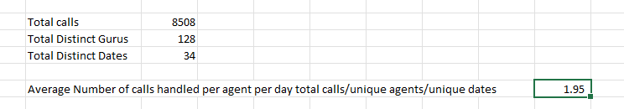

**Identifying High-Demand Periods**

**● We used pivot tables to determine the call volume and average call duration for**

**each hour of the day. From these, we can see specific peak periods with high call**

**volumes and potentially longer call durations, which may signal more complex**

**issues or slower response times.**

**● Recommendation: Schedule more agents during peak hours (e.g., early**

**mornings and late afternoons). This targeted approach ensures that agents aren’t**

**overloaded during busy times, which can lead to burnout and reduced customer**

**satisfaction.**

1. **What new technologies or tools could be implemented to enhance call centre operations and customer service?**

Technologies and Tools to Enhance Call Centre Operations and Customer Service

The implementation of advanced technologies and tools can significantly improve call centre efficiency and customer satisfaction. Here are some key recommendations:

  
  
  
AI-Powered Tools

1. Chatbots and Virtual Assistants
   * Functionality: Automate FAQs and routine queries using tools like Zendesk AI, ChatGPT, or Google Dialog flow.
   * Benefits: Reduce agent workloads by redirecting basic tasks, allowing them to focus on complex cases.
2. Sentiment Analysis Tools
   * Functionality: Use AI to analyse customer emotions during interactions.
   * Examples: IBM Watson Tone Analyzer, Microsoft Azure AI.
   * Benefits: Identify dissatisfaction early for proactive resolutions.
3. Predictive Analytics
   * Functionality: Anticipate peak times, customer needs, or workload fluctuations.
   * Examples: Salesforce Einstein, SAP Analytics Cloud.
   * Benefits: Ensure optimal staffing and personalized experiences.

Workforce Optimization (WFO) Tools

1. Smart Scheduling and Forecasting
   * Tools: WFM, NICE Workforce Management.
   * Benefits: Minimize wait times and idle periods.
2. Performance Analytics
   * Functionality: Track agent performance metrics such as resolution rates and feedback scores.
   * Tools: Five9 WFO, Verint.
   * Benefits: Facilitate training and enhance accountability.

Customer Relationship Management (CRM) Enhancements

1. Integrated CRM Systems
   * Tools: Salesforce, HubSpot, Zendesk.
   * Benefits: Centralized customer data enables personalized service.
2. Self-Service Portals
   * Functionality: Provide knowledge bases and FAQs for customer self-help.
   * Examples: Freshdesk, integrated CRM platforms.

Omni-Channel Communication Platforms

* Unified Communication Tools: Platforms like Genesys Cloud CX and Twilio consolidate interactions across chat, email, social media, and phone calls.
* Benefits: Improve customer experience by reducing interaction friction.

Quality Assurance and Monitoring Tools

1. Call Recording and Analysis
   * Tools: Observe.AI, CallMiner.
   * Benefits: Evaluate and improve call quality and compliance.
2. Speech-to-Text and Keyword Detection
   * Tools: Otter.ai, Rev AI.
   * Benefits: Enhance documentation and issue tracking.

Cloud-Based Contact Centre

* Transitioning Tools: Amazon Connect, RingCentral, 8x8.
* Benefits: Enhance scalability, integration, and remote work capabilities while reducing costs.

Advanced IVR (Interactive Voice Response) Systems

* AI-Driven IVR: Use natural language processing (NLP) to simplify IVR interactions.
* Example: Nuance AI-powered IVR.
* Benefits: Faster resolutions and improved customer experiences.

Customer Feedback and Engagement Tools

1. Real-Time Feedback Collection
   * Tools: Medallia, SurveyMonkey, post-call surveys.
   * Benefits: Gain instant insights for service improvement.
2. Gamification for Agent Engagement
   * Tools: Playvox , Ambition.
   * Benefits: Motivate and boost agent performance.

Recommendations for Enhancing Call Centre Operations

1. Implement AI-Powered Chatbots and Voice Bots
   * Action Steps:
     + Choose an integration-friendly chatbot platform.
     + Train with historical interaction data.
     + Continuously monitor and refine its performance.
2. Adopt Omnichannel Integration
   * Action Steps:
     + Select a robust omnichannel solution.
     + Train agents for cross-channel interaction management.
     + Review interactions to maintain seamless experiences.
3. Transition to Cloud-Based Call Centre Solutions (CCaaS)
   * Action Steps:
     + Identify the right CCaaS provider.
     + Plan migration in phases to reduce disruption.
     + Train agents on cloud tools effectively.
4. Utilize Automatic Call Distributors (ACD)
   * Action Steps:
     + Define skill-based routing criteria.
     + Monitor call routing efficiency and make adjustments.
     + Evaluate impact on resolution times and satisfaction.
5. Integrate Computer Telephony Integration (CTI)
   * Action Steps:
     + Implement a CTI system that integrates seamlessly with CRMs.
     + Train agents on using features like screen pops and click-to-call.
     + Assess efficiency improvements regularly.

By implementing these technologies and strategies, the call centre can boost efficiency, reduce operational costs, and enhance customer satisfaction.

1. **What metrics should be included in the final dashboard to provide a comprehensive view of call centre performance and guide investment decisions?**  
     
   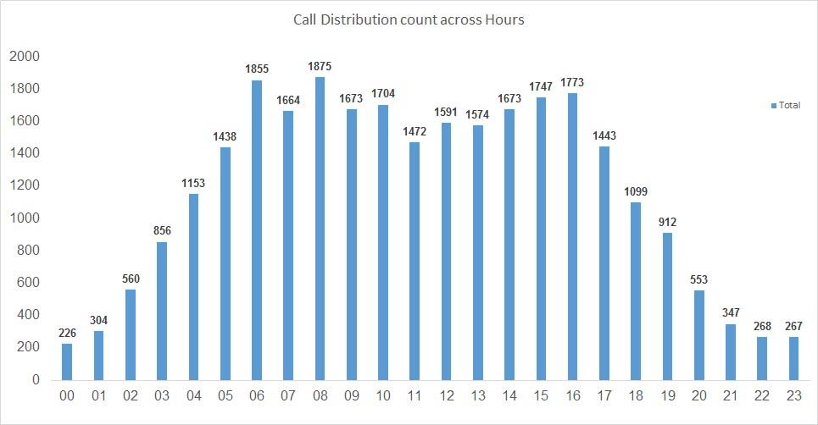  
     
   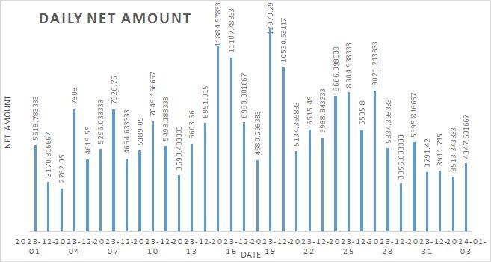

Operational Metrics

Metrics for Call Centre Optimization

Efficiency, Agent Performance, and Resource Utilization

1. Call Volume
   * Tracks total inbound and outbound calls.
   * Analyse trends over time (hourly, daily, monthly).
2. Average Handle Time (AHT)
   * Measures the average time required to resolve a call.
   * Highlights areas needing efficiency improvements or additional training.
3. Peak Call Times
   * Identifies high-traffic periods to optimize scheduling and resource allocation.
4. Call Abandonment Rate
   * Percentage of calls disconnected by customers before resolution.
   * A lower rate reflects better queue and wait time management.
5. Agent Utilization Rate
   * Percentage of time agents spend on calls versus idle.
   * Indicates overall productivity.
6. Call Queue Length and Wait Times
   * Monitors customer waiting durations.
   * Long queues may signal understaffing or process inefficiencies.

Financial Metrics

Focus on financial health and ROI evaluation:

1. Revenue per Call/Chat
   * Tracks average revenue generated per customer interaction.
   * Critical for assessing operational ROI.
2. Agent Earnings
   * Monitors agent payouts and identifies significant cost factors.
3. Operational Costs
   * Includes salaries, software, hardware, and general overheads.
   * Helps in detailed cost-benefit analysis.
4. Net Revenue
   * Total income after deducting operational expenses.
   * Provides a clear picture of profitability.
5. Refund Rates
   * Tracks transactions leading to refunds.
   * Serves as an indicator of service quality and impacts profitability.

Customer-Centric Metrics

Prioritize satisfaction and loyalty:

1. Customer Satisfaction Score (CSAT)
   * Collected via post-call surveys or feedback tools.
   * Essential for evaluating service quality.
2. Repeat Caller Rate
   * Percentage of customers who call multiple times.
   * A high rate can signify either loyalty or unresolved issues.
3. Rating per Interaction
   * Average customer ratings for calls or specific agents.
   * Helps measure individual service impact.

Agent Performance Metrics

Evaluate individual contributions:

1. Agent Call Volume
   * Number of calls managed by each agent.
   * Highlights workload distribution.
2. Agent Rating Scores
   * Customer feedback on agents’ performance.
   * Identifies top performers and those needing support.
3. Average Agent Response Time
   * Tracks the time agents take to attend to queued calls.
4. Agent Attrition Rate
   * Monitors turnover rates.
   * Indicates levels of job satisfaction and organizational stability.

Predictive and Comparative Metrics

For planning and competitive analysis:

1. Forecasted Call Volume
   * Predicts traffic patterns using historical data.
   * Informs resource and staffing decisions.
2. Benchmark Metrics
   * Compares internal performance against industry standards or competitors (e.g., AstroGuru vs. AstroSage).
3. Seasonal Performance Trends
   * Examines call centre performance during specific seasons, such as festive periods.

Visualization and Aggregation Suggestions

* Visualizations:
  + Line Graphs: Display call volume trends over time.
  + Bar Charts: Compare agent performance metrics.
  + Pie Charts: Show call type distribution or revenue sources.
  + Heatmaps: Highlight peak traffic periods.
  + Stacked Charts: Compare revenue versus operational costs.
* Aggregation Functions:
  + SUM: Calculate total call volumes and revenues.
  + AVERAGE: Determine average handle times and customer ratings.
  + COUNT: Count repeat callers or specific call events.
  + MAX/MIN: Identify peak and low-performance times.

By incorporating these metrics and visualization tools, the call center can:

* Streamline operations and improve agent productivity.
* Optimize resource allocation.
* Enhance customer satisfaction and service delivery.
* Empower agents to work effectively without unnecessary burden, maximizing efficiency and results.

1. **How would you allocate a 1 crore rupee investment to optimize operational efficiency, enhance customer satisfaction, and boost profitability, and what analysis-based recommendations would you offer to support this?**

**[you have to give bullet pointers in order to answer this question]**

If get chance to optimize operational efficiency enhance customer satisfaction and boost profitability then I’ll plan 1Cr of investment like this  
  
Approach to Investment Allocation

1. Define Objectives

* Operational Efficiency: Identify opportunities to streamline processes, reduce costs, and improve productivity.
* Customer Satisfaction: Focus on enhancing the customer experience through improved service and engagement.
* Profitability: Target revenue-generating initiatives and cost-saving measures to strengthen the bottom line.

2. Conduct a Needs Assessment

* Data Analysis: Evaluate current operational metrics, customer feedback, and financial performance to highlight key improvement areas.
* Stakeholder Input: Gather insights from employees, customers, and leadership to pinpoint challenges and opportunities.

3. Prioritize Investment Areas

* Categorization: Group potential investments into technology, training, process improvement, and marketing.
* ROI Evaluation: Assess projected improvements in efficiency, customer satisfaction, and profitability for each category to prioritize.

4. Allocate Budget

* Budget Plan: Distribute the ₹1 crore investment across prioritized categories based on their impact potential and ROI.
* Milestones: Establish clear timelines and objectives for implementing investments.

5. Monitor and Adjust

* Define KPIs: Set metrics to track the success of investments (e.g., customer satisfaction, call resolution rates, or operational costs).
* Regular Reviews: Periodically assess performance, refine strategies, and reallocate resources if necessary.

Proposed Allocation of ₹1 Crore Investment

1. Technology Upgrades (40% - ₹40 lakhs)

* Implement a comprehensive Customer Relationship Management (CRM) system to enhance customer data management and interactions.
* Deploy automation tools to improve efficiency in routine tasks.

2. Training and Development (30% - ₹30 lakhs)

* Develop employee training programs covering customer service skills, product knowledge, and technology usage.
* Offer leadership training to improve management skills and staff engagement.

3. Process Improvement Initiatives (20% - ₹20 lakhs)

* Implement lean methodologies to identify and eliminate inefficiencies.
* Establish quality assurance programs to maintain consistent service standards.

4. Marketing and Customer Engagement (10% - ₹10 lakhs)

* Introduce customer feedback systems for continuous improvement through real-time insights.
* Launch loyalty programs to increase customer retention and satisfaction.

Insights

1. Data-Driven Decision Making: Leverage analytics to gain insights into customer behaviour, process inefficiencies, and trends for informed planning.
2. Employee Engagement: Invest in staff training and development to improve skills, morale, and retention, translating into better service.
3. Customer-Centric Approach: Prioritize feedback and engagement for long-term loyalty and satisfaction.
4. Technology as an Enabler: Modern tools streamline operations, reduce costs, and enhance customer experiences, fostering growth.

Recommendations

1. Implement a Comprehensive CRM System

* Action: Adopt a CRM solution that integrates with existing platforms and offers robust analytics.
* Impact: Enhanced customer interactions and marketing efficiency, leading to higher satisfaction and retention.

2. Prioritize Employee Training and Development

* Action: Create structured programs for soft and technical skills, emphasizing customer service excellence.
* Impact: Improved agent performance and customer service quality, boosting satisfaction.

3. Adopt Lean Methodologies

* Action: Train teams on lean principles and empower them to drive process improvements.
* Impact: Reduced costs and increased operational efficiency, enhancing profitability.

4. Establish a Customer Feedback Loop

* Action: Use surveys and feedback tools to gather real-time insights into customer needs and expectations.
* Impact: Continuous improvement in service delivery aligned with customer preferences.

5. Monitor KPIs and Adapt Strategies

* Action: Regularly track performance metrics, such as CSAT, FCR, and AHT, to guide future investments.
* Impact: A flexible strategy ensures alignment with dynamic market conditions and customer demands.

Analysis-Based Recommendations

1. Peak Call Period Insights: Use historical trends to optimize staffing during high-demand periods.
2. Agent Performance Metrics: Allocate resources for training underperforming agents identified by key performance metrics.
3. Customer Satisfaction Drivers: Focus on service delivery improvements driven by feedback analytics.
4. ROI Measurement: Track changes in FCR, CSAT, and revenue per call post-investment to evaluate outcomes.

By strategically implementing these initiatives, the call centre can achieve sustainable growth, elevate customer satisfaction, and enhance profitability.